
QUALITY ALERT

Customer: HPAC Date: July 3, 2020
Die: 15191 / 15192 / 15238 Colour: ALL
Type of Complaint: HPAC Complaint

Q.A # Q.I.R # CUSTOMER NCR #

Description: Bottom Buggy Liner Panels warping / damaged causing panels to be wavy
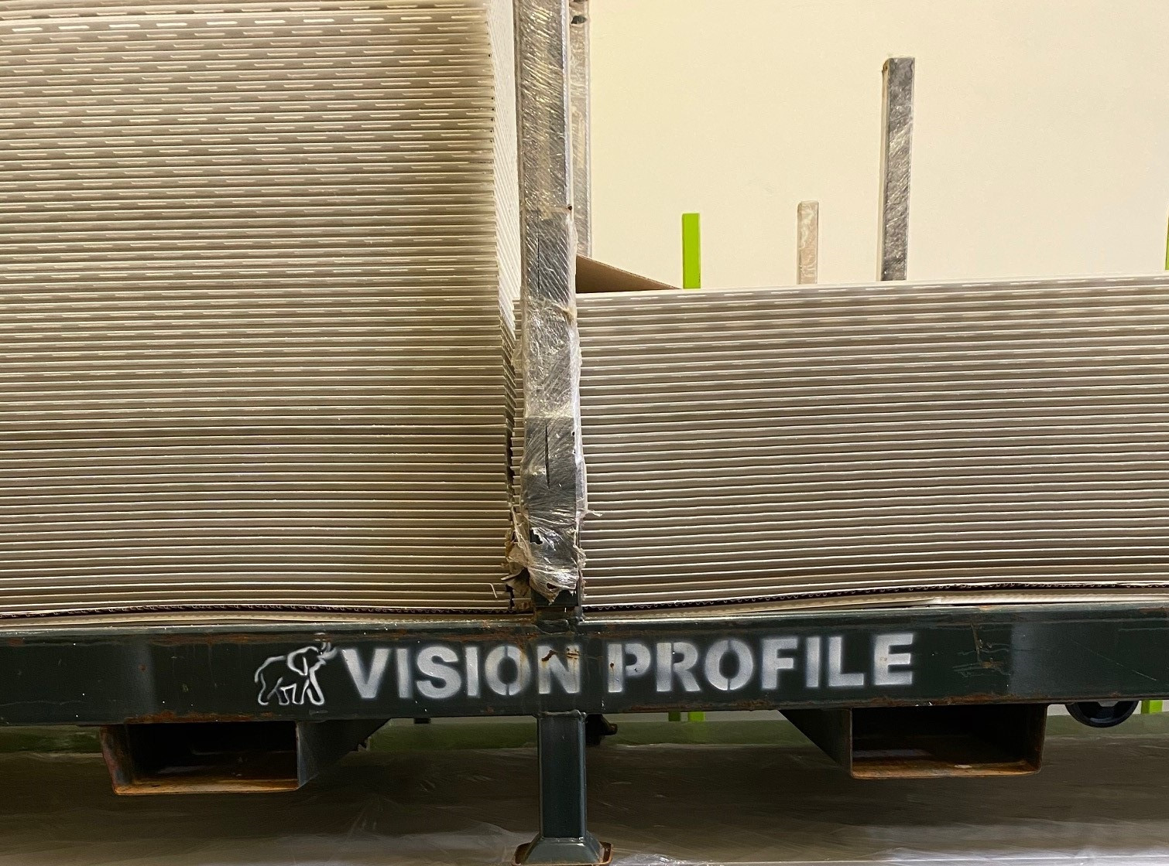

CHECK BUGGY AND BUGGY LINER PANELS ARE NOT DAMAGED / WARPED

BY SIGNING BELOW, YOU ACKNOWLEDGE THE PROBLEM ABOVE AND AGREE TO MONITOR THIS ISSUE IN FUTURE PRODUCTION RUNS.
DAY SHIFT |  | AFTERNOON SHIFT |  | NIGHT SHIFT
NAME | SIGNATURE | NAME | SIGNATURE | NAME | SIGNATURE

